Internal Tangency

Definition
# Source: AI Source: Provided by: [Data Path: Persons Table -> ID Column: 1, Name_En Column: Motasem Essam] -> From: [ChatGPT] on [7/25/2026]
Internal Tangency occurs when one circle lies inside another circle and the two circles touch at exactly one point.
The smaller circle is inside the larger circle, and they have exactly one common point called the point of tangency or point of contact.
If the circles are $C_{1}$ and $C_{2}$:
$$\boxed{C_{1}∩C_{2}=\{P\}}$$
where $P$ is the point of tangency.
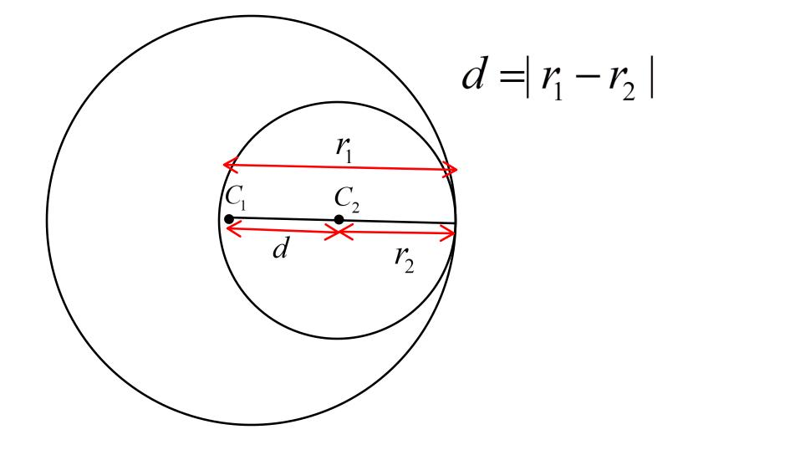
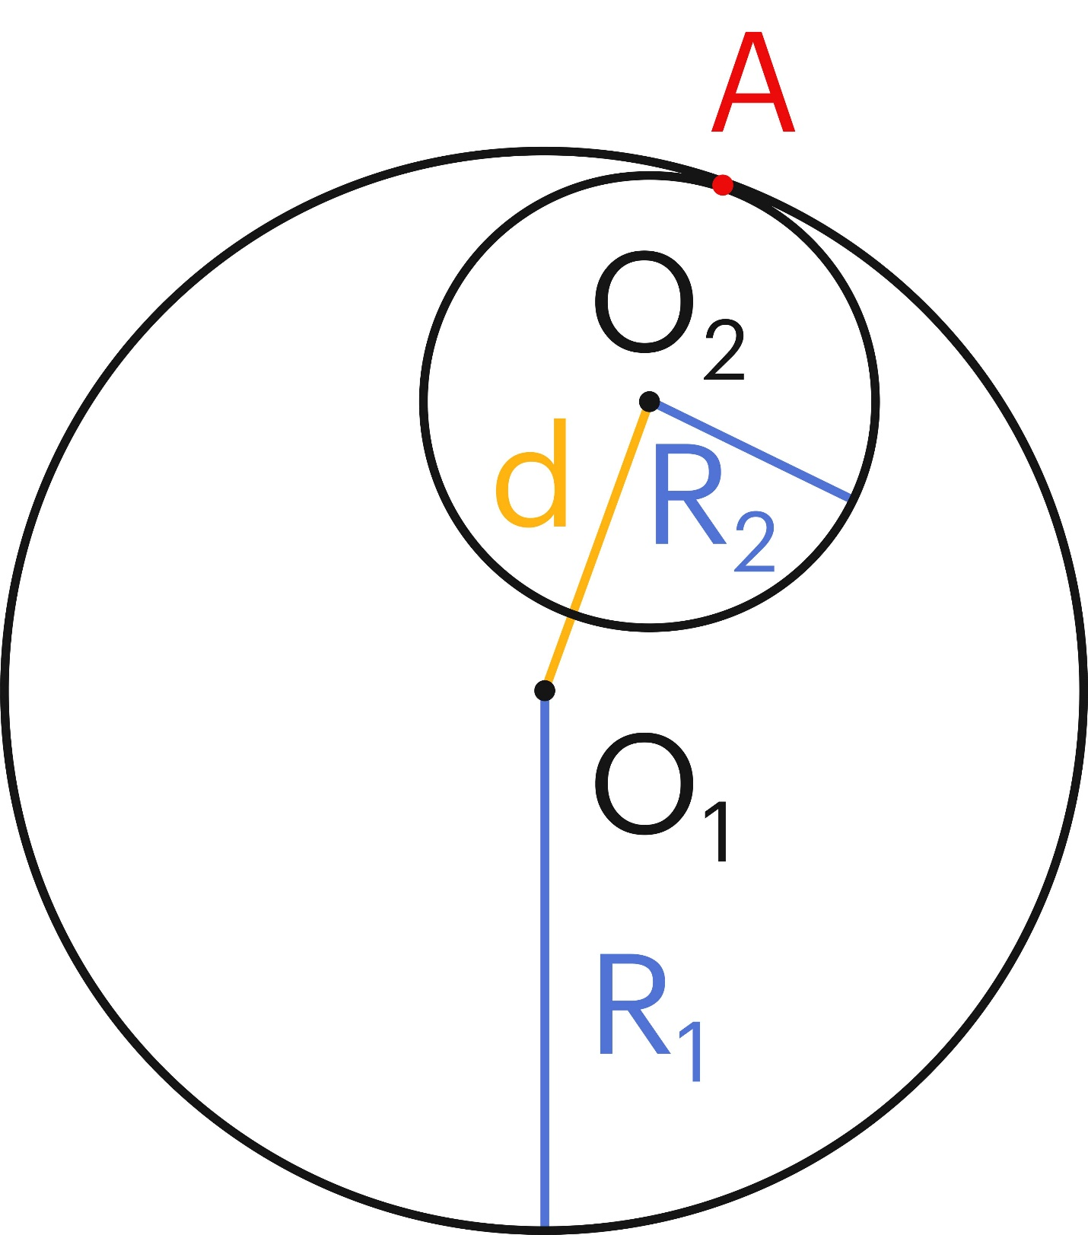
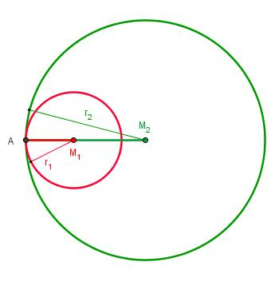
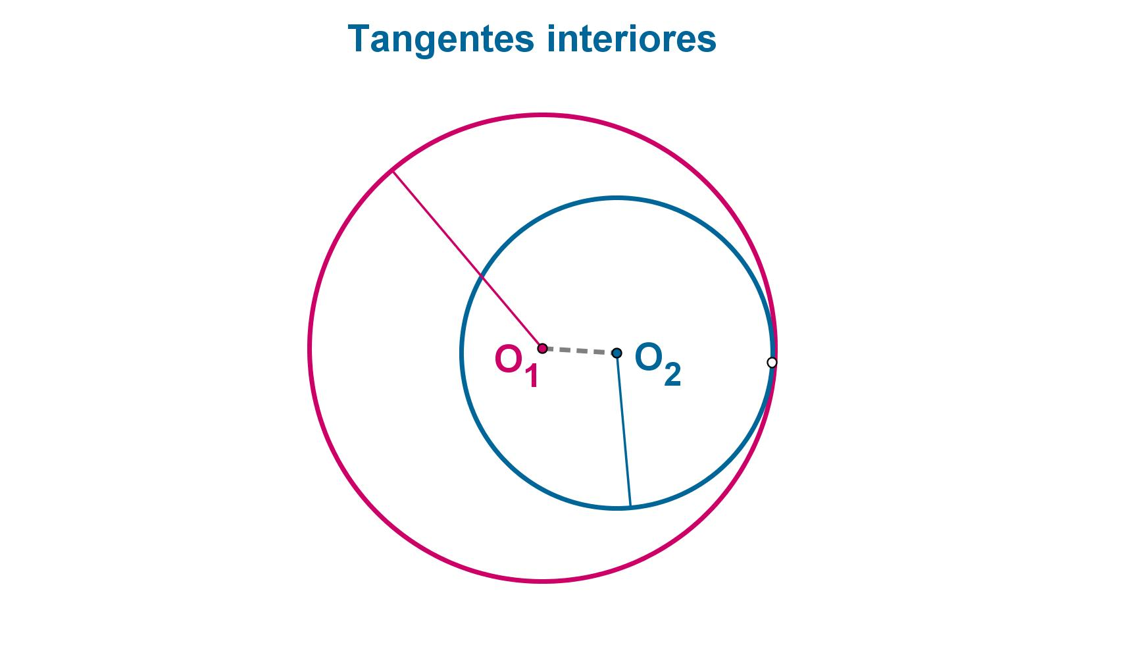

Purpose
# Source: AI Source: Provided by: [Data Path: Persons Table -> ID Column: 1, Name_En Column: Motasem Essam] -> From: [ChatGPT] on [7/25/2026]
Internal tangency is used to:
- Determine when two circles touch internally.
- Calculate the distance between their centers.
- Analyze relationships between circles.
- Solve circle geometry problems.
- Construct tangent circles.
- Design circular mechanical components.
- Create precise CAD constructions.
- Analyze circular boundaries and structures.

Fundamental Idea
# Source: AI Source: Provided by: [Data Path: Persons Table -> ID Column: 1, Name_En Column: Motasem Essam] -> From: [ChatGPT] on [7/25/2026]
Consider a large circle containing a smaller circle:
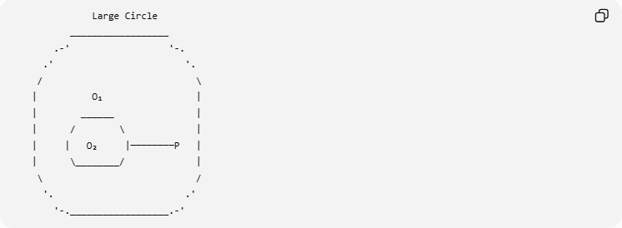
Large Circle
__________________
.-' '-.
.' '.
/ \
| O₁ |
| ______ |
| / \ |
| | O₂ |────────P |
| \________/ |
\ /
'. .'
'-.__________________.-'
The smaller circle touches the larger circle at exactly one point:
$$\boxed{P}$$
The centers and the point of tangency are collinear:
$$\boxed{O_{1},O_{2},P}$$

Mathematical Condition
# Source: AI Source: Provided by: [Data Path: Persons Table -> ID Column: 1, Name_En Column: Motasem Essam] -> From: [ChatGPT] on [7/25/2026]
Let:
- $R$= radius of the larger circle.
- $r$= radius of the smaller circle.
- $d$= distance between their centers.
For internal tangency:
$$\boxed{d=R-r}$$
assuming:
$$\boxed{R>r}$$
The distance between the centers equals the difference between the radii.
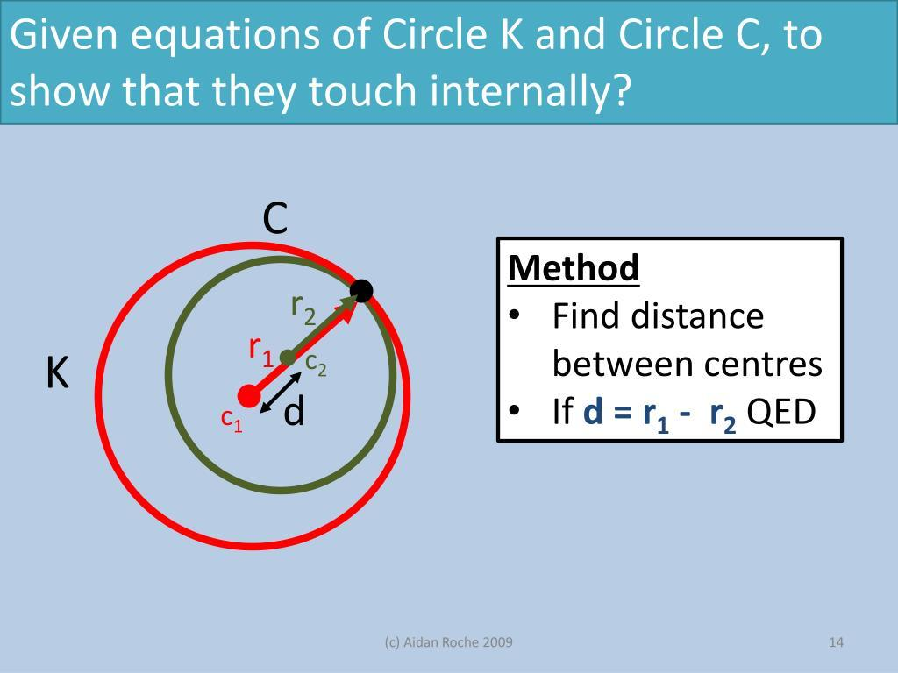
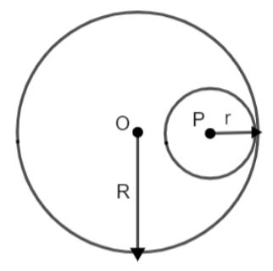

Why Is the Distance the Difference of the Radii?
# Source: AI Source: Provided by: [Data Path: Persons Table -> ID Column: 1, Name_En Column: Motasem Essam] -> From: [ChatGPT] on [7/25/2026]
Let $O_{1}$ be the center of the larger circle and $O_{2}$ the center of the smaller circle.
At the point of tangency $P$:
$$O_{1}P=R$$
and:
$$O_{2}P=r$$
Because the smaller circle is inside the larger circle:
$$O_{1}O_{2}+O_{2}P=O_{1}P$$
Therefore:
$$d+r=R$$
So:
$$\boxed{d=R-r}$$

Point of Tangency
# Source: AI Source: Provided by: [Data Path: Persons Table -> ID Column: 1, Name_En Column: Motasem Essam] -> From: [ChatGPT] on [7/25/2026]
The point where the two circles touch is called the:
$$\boxed{\text{Point of Tangency}}$$
or:
$$\boxed{\text{Point of Contact}}$$
At this point:
$$\boxed{P∈C_{1}}$$
and:
$$\boxed{P∈C_{2}}$$
Therefore:
$$\boxed{P∈C_{1}∩C_{2}}$$
There is exactly one common point.

Number of Common Points
# Source: AI Source: Provided by: [Data Path: Persons Table -> ID Column: 1, Name_En Column: Motasem Essam] -> From: [ChatGPT] on [7/25/2026]
Internally tangent circles have:
$$\boxed{1}$$
common point.
Therefore:
$$\boxed{\left|C_{1}∩C_{2}\right|=1}$$
This is similar to external tangency in terms of the number of common points, but the position of the circles is different.

Example 1 — Equal Center Alignment
# Source: AI Source: Provided by: [Data Path: Persons Table -> ID Column: 1, Name_En Column: Motasem Essam] -> From: [ChatGPT] on [7/25/2026]
Suppose the larger circle has radius:
$$R=10$$
and the smaller circle has radius:
$$r=4$$
For internal tangency:
$$d=R-r$$
Therefore:
$$d=10-4 \\ \boxed{d=6}$$
The centers must be $6$ units apart.
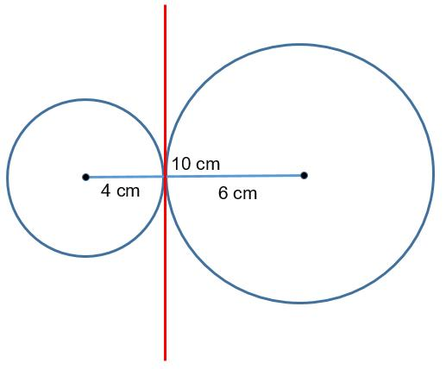
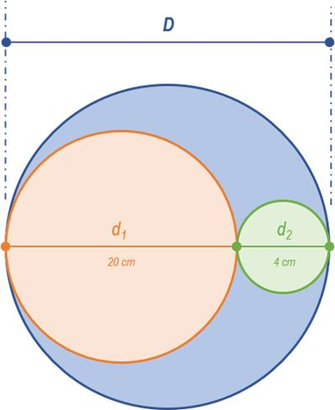

Example 2 — Determining Internal Tangency
# Source: AI Source: Provided by: [Data Path: Persons Table -> ID Column: 1, Name_En Column: Motasem Essam] -> From: [ChatGPT] on [7/25/2026]
Suppose:
$$R=12 \\ r=5$$
and:
$$d=7$$
Calculate:
$$R-r=12-5=7$$
Since:
$$d=R-r$$
the circles are internally tangent.
$$\boxed{\text{Internal Tangency}}$$

Example 3 — Not Internally Tangent
# Source: AI Source: Provided by: [Data Path: Persons Table -> ID Column: 1, Name_En Column: Motasem Essam] -> From: [ChatGPT] on [7/25/2026]
Suppose:
$$R=12 \\ r=5$$
but:
$$d=4$$
For internal tangency, we need:
$$d=12-5=7$$
But:
$$4≠7$$
Therefore, the circles are not internally tangent.
Since:
$$d<R-r$$
the smaller circle lies completely inside the larger circle without touching it.

Internal Tangency vs. External Tangency
# Source: AI Source: Provided by: [Data Path: Persons Table -> ID Column: 1, Name_En Column: Motasem Essam] -> From: [ChatGPT] on [7/25/2026]
These two relationships are especially important.
External Tangency
The circles touch from the outside:
$$\boxed{d=r_{1}+r_{2}}$$
Internal Tangency
One circle is inside the other:
$$\boxed{d=R-r}$$
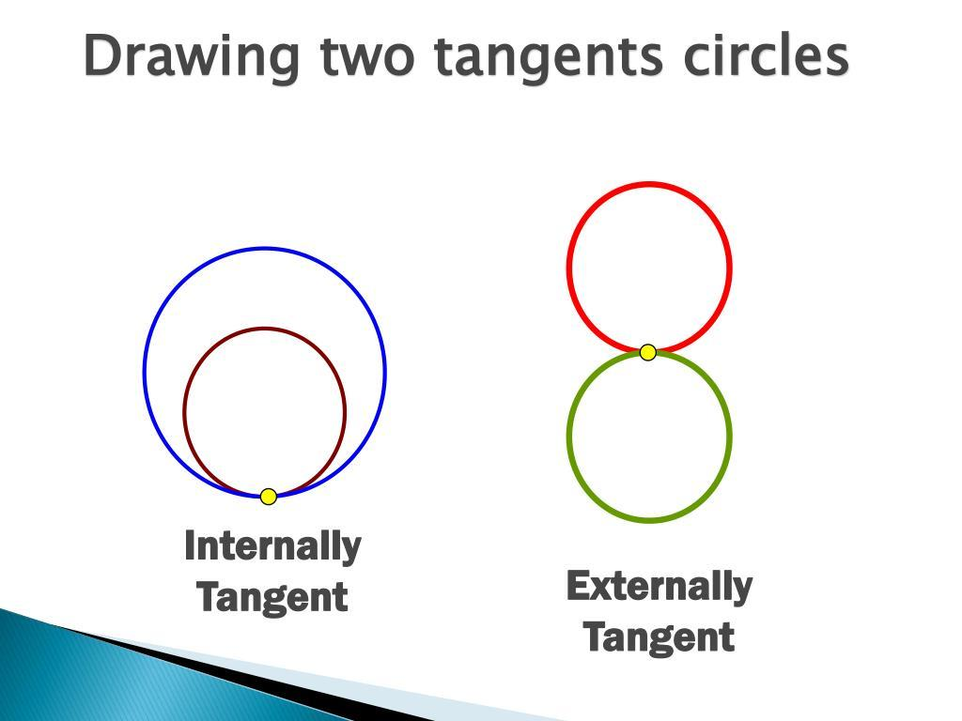
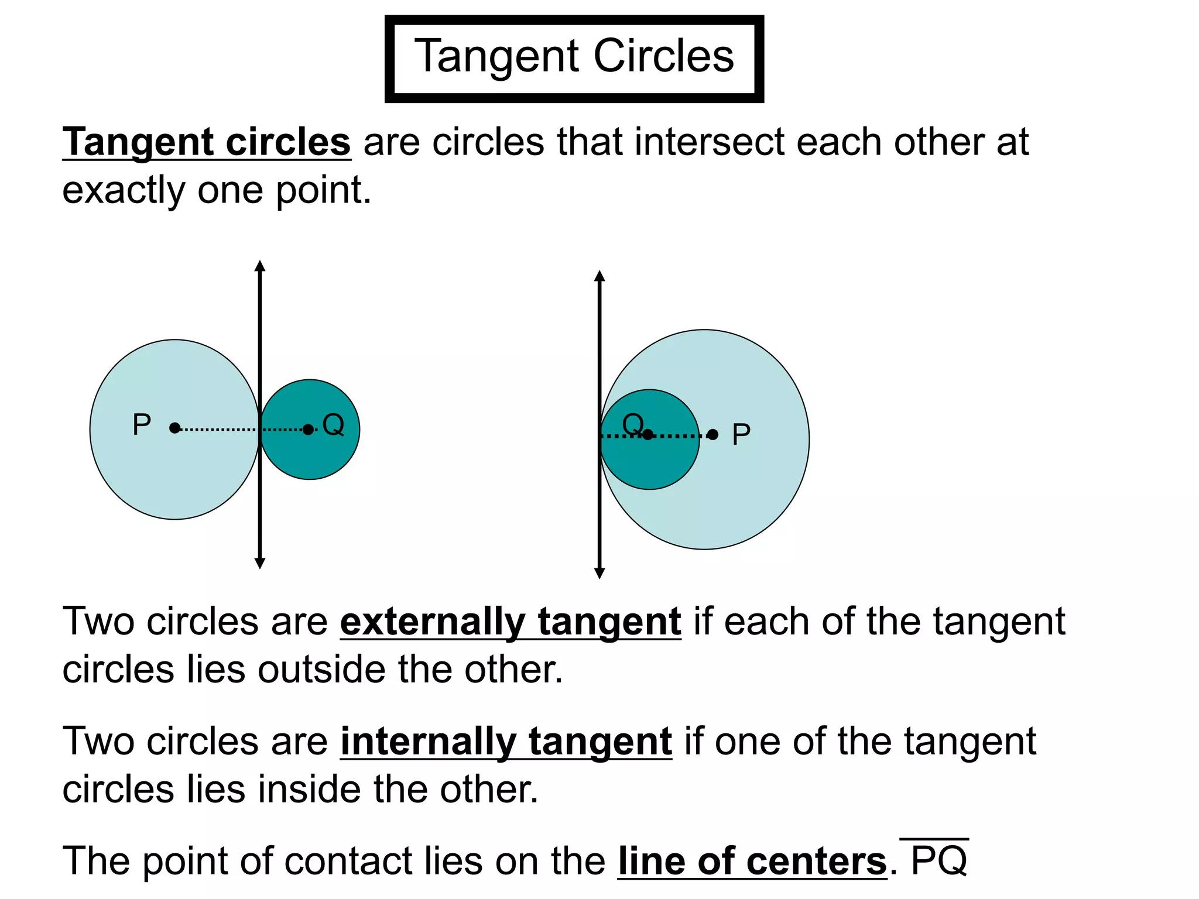
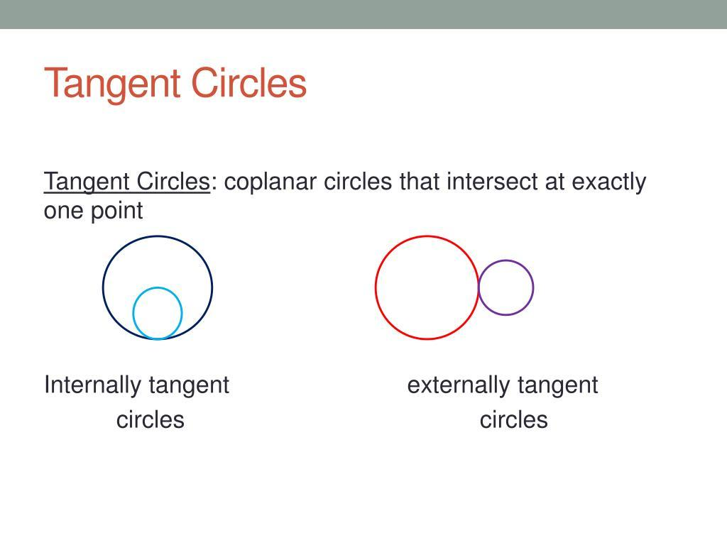

Centers and Point of Tangency
# Source: AI Source: Provided by: [Data Path: Persons Table -> ID Column: 1, Name_En Column: Motasem Essam] -> From: [ChatGPT] on [7/25/2026]
For internally tangent circles, the centers and point of tangency are collinear.
$$\boxed{O_{1},O_{2},P}$$
The smaller center lies between the larger center and the point of tangency:
$$\boxed{O_{1}-O_{2}-P}$$
where $O_{1}$ is the center of the larger circle.
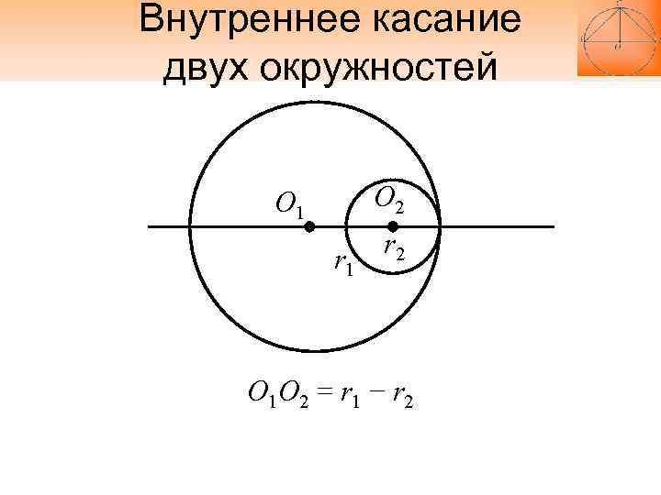
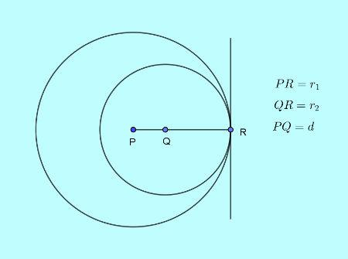

Radius Relationships
# Source: AI Source: Provided by: [Data Path: Persons Table -> ID Column: 1, Name_En Column: Motasem Essam] -> From: [ChatGPT] on [7/25/2026]
For the larger circle:
$$\boxed{O_{1}P=R}$$
For the smaller circle:
$$\boxed{O_{2}P=r}$$
The center distance is:
$$\boxed{O_{1}O_{2}=R-r}$$
Therefore:
$$\boxed{O_{1}O_{2}+O_{2}P=O_{1}P}$$

Common Tangent at the Point of Contact
# Source: AI Source: Provided by: [Data Path: Persons Table -> ID Column: 1, Name_En Column: Motasem Essam] -> From: [ChatGPT] on [7/25/2026]
At the point of internal tangency P, both circles have the same tangent line.
The tangent line is perpendicular to the line connecting their centers:
$$\boxed{l⊥O_{1}O_{2}}$$
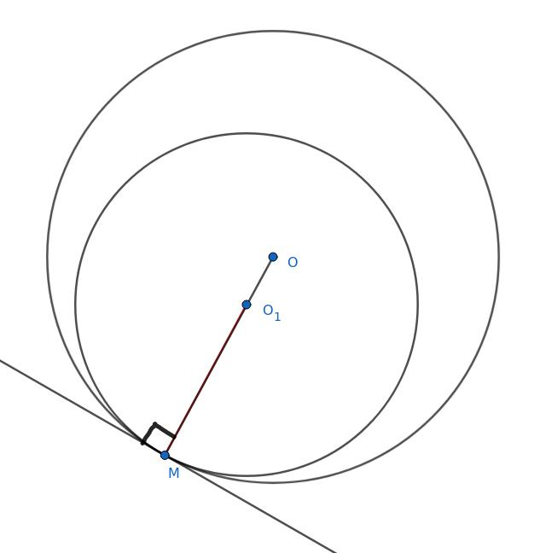
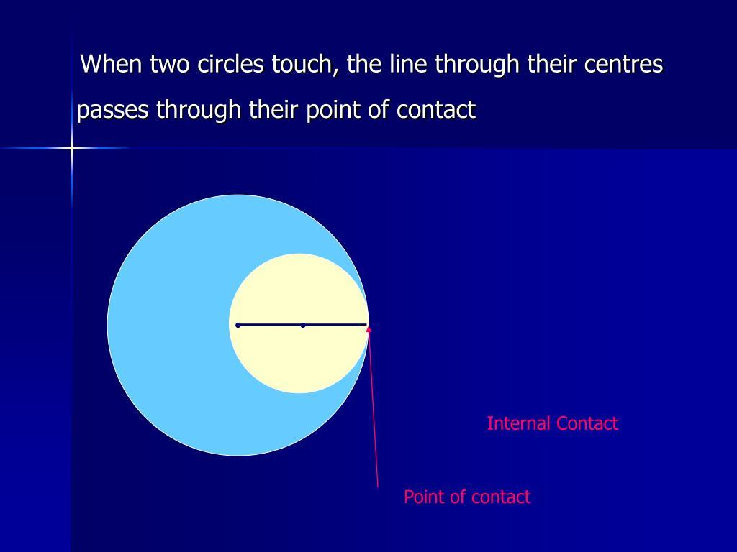
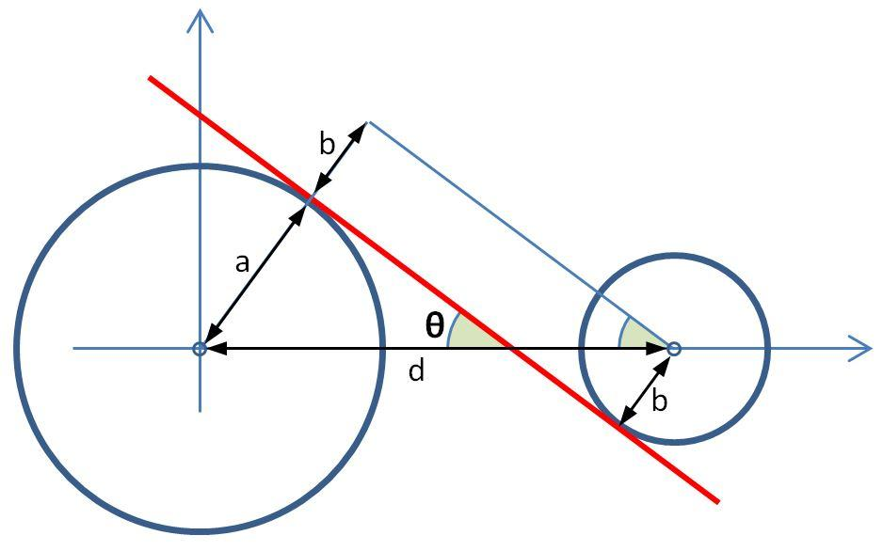
Therefore:
[
\boxed{\angle(\ell,O_1O_2)=90^\circ}
]

Internal Tangency and Intersection
# Source: AI Source: Provided by: [Data Path: Persons Table -> ID Column: 1, Name_En Column: Motasem Essam] -> From: [ChatGPT] on [7/25/2026]
Internal tangency can be understood as a special case between two circles.
For a larger circle of radius $R$ and smaller circle of radius $r$:
Smaller circle completely inside
$$\boxed{d<R-r}$$
There is no intersection.
Internal Tangency
$$\boxed{d=R-r}$$
There is exactly one common point.
Two-Point Intersection
$$\boxed{R-r<d<R+r}$$
There are two common points.
External Tangency
$$\boxed{d=R+r}$$
There is exactly one common point.
Completely Separate
$$\boxed{d>R+r}$$
There is no intersection.
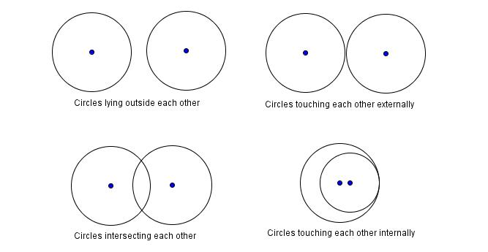
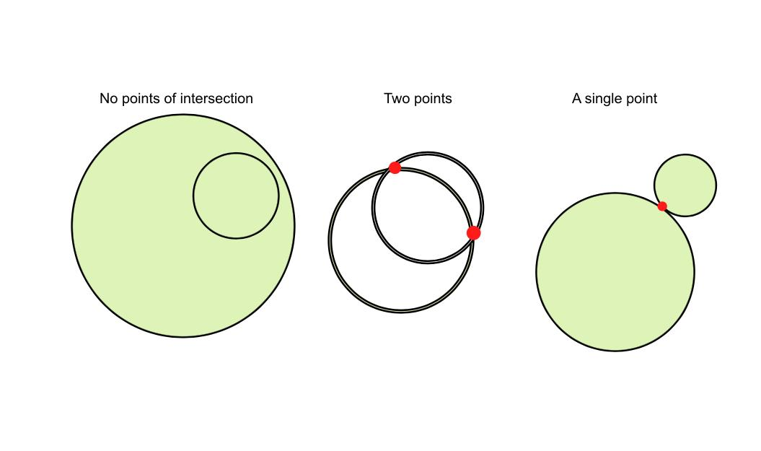
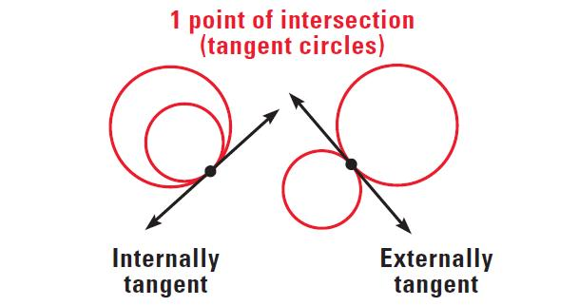
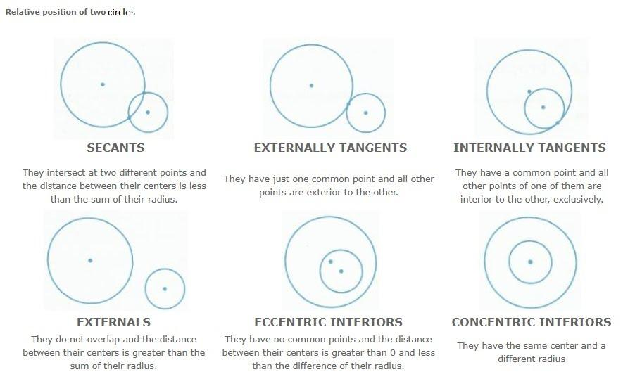

Complete Circle Relationship Classification
# Source: AI Source: Provided by: [Data Path: Persons Table -> ID Column: 1, Name_En Column: Motasem Essam] -> From: [ChatGPT] on [7/25/2026]
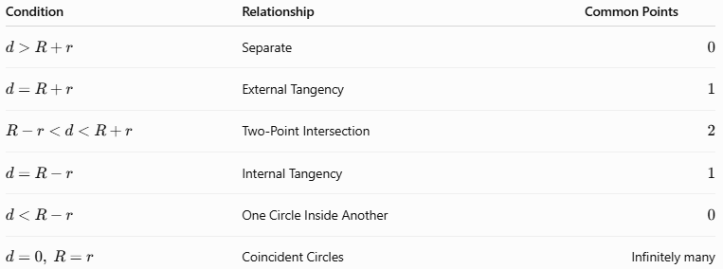
Condition | Relationship | Common Points
$$d>R+r$$ | Separate | $$0$$
$$d=R+r$$ | External Tangency | $$1$$
$$R-r<d<R+r$$ | Two-Point Intersection | $$2$$
$$d=R-r$$ | Internal Tangency | $$1$$
$$d<R-r$$ | One Circle Inside Another | $$0$$
$$d=0, R=r$$ | Coincident Circles | Infinitely many

Coordinate Geometry
# Source: AI Source: Provided by: [Data Path: Persons Table -> ID Column: 1, Name_En Column: Motasem Essam] -> From: [ChatGPT] on [7/25/2026]
Suppose the centers are:
$$O_{1}=\left(x_{1},y_{1}\right)$$
and:
$$O_{2}=\left(x_{2},y_{2}\right)$$
The distance between the centers is:
$$d=\sqrt{{\left(x_{2}-x_{1}\right)}^{2}+{\left(y_{2}-y_{1}\right)}^{2}}$$
For internal tangency:
$$\boxed{\sqrt{{\left(x_{2}-x_{1}\right)}^{2}+{\left(y_{2}-y_{1}\right)}^{2}}=R-r}$$
where:
$$R>r$$

Coordinate Example
# Source: AI Source: Provided by: [Data Path: Persons Table -> ID Column: 1, Name_En Column: Motasem Essam] -> From: [ChatGPT] on [7/25/2026]
Suppose:
$$O_{1}=\left(0,0\right)$$
and:
$$O_{2}=\left(3,4\right)$$
The larger circle has radius:
$$R=8$$
and the smaller circle has radius:
$$r=3$$
Calculate the center distance:
$$d=\sqrt{{\left(3-0\right)}^{2}+{\left(4-0\right)}^{2}} \\ d=\sqrt{9+16} \\ d=\sqrt{25} \\ d=5$$
Now calculate:
$$R-r=8-3=5$$
Therefore:
$$\boxed{d=R-r}$$
So the circles are internally tangent.

Internal Tangency vs. No Intersection
# Source: AI Source: Provided by: [Data Path: Persons Table -> ID Column: 1, Name_En Column: Motasem Essam] -> From: [ChatGPT] on [7/25/2026]
Consider a large circle and a smaller circle.
Internal Tangency
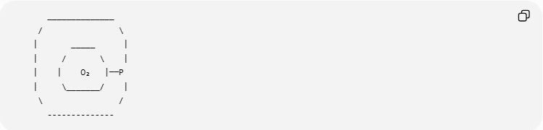
______________
/ \
| _____ |
| / \ |
| | O₂ |──P
| \_______/ |
\ /
--------------
The smaller circle touches the larger circle.
$$\boxed{d=R-r}$$
No Intersection
The smaller circle is completely inside but does not touch the larger circle.
$$\boxed{d<R-r}$$
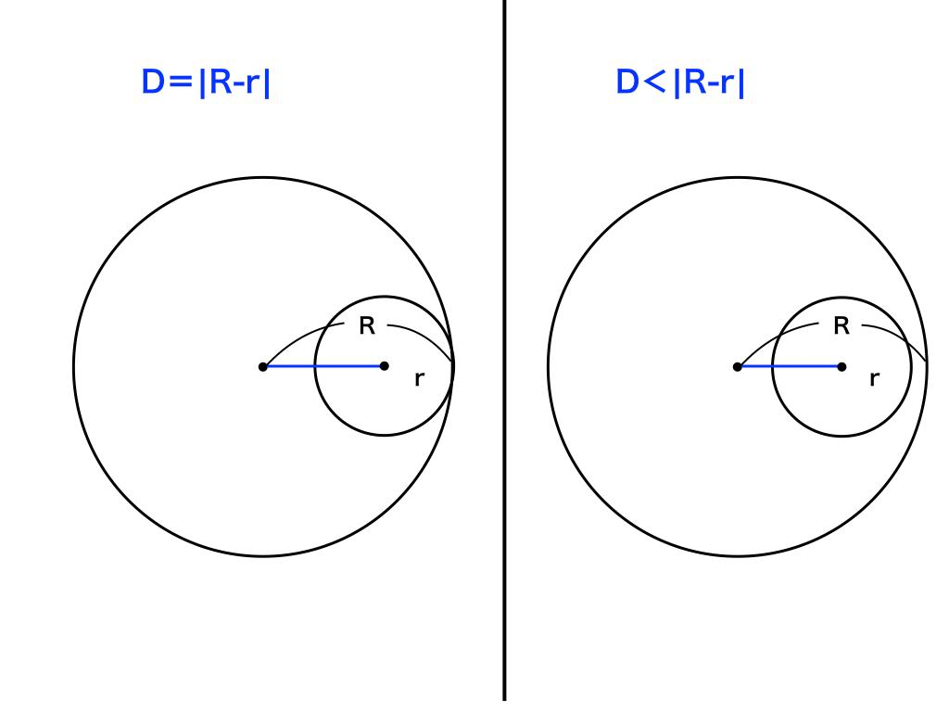

Internal Tangency vs. Two-Point Intersection
# Source: AI Source: Provided by: [Data Path: Persons Table -> ID Column: 1, Name_En Column: Motasem Essam] -> From: [ChatGPT] on [7/25/2026]
When:
$$d=R-r$$
the circles touch at exactly one point.
When:
$$R-r<d<R+r$$
the circles cross at two points.
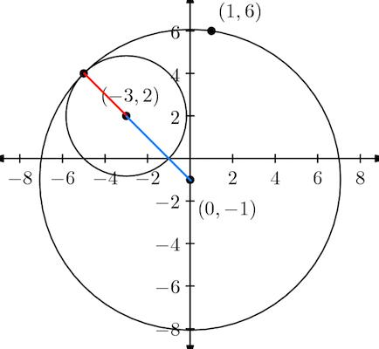
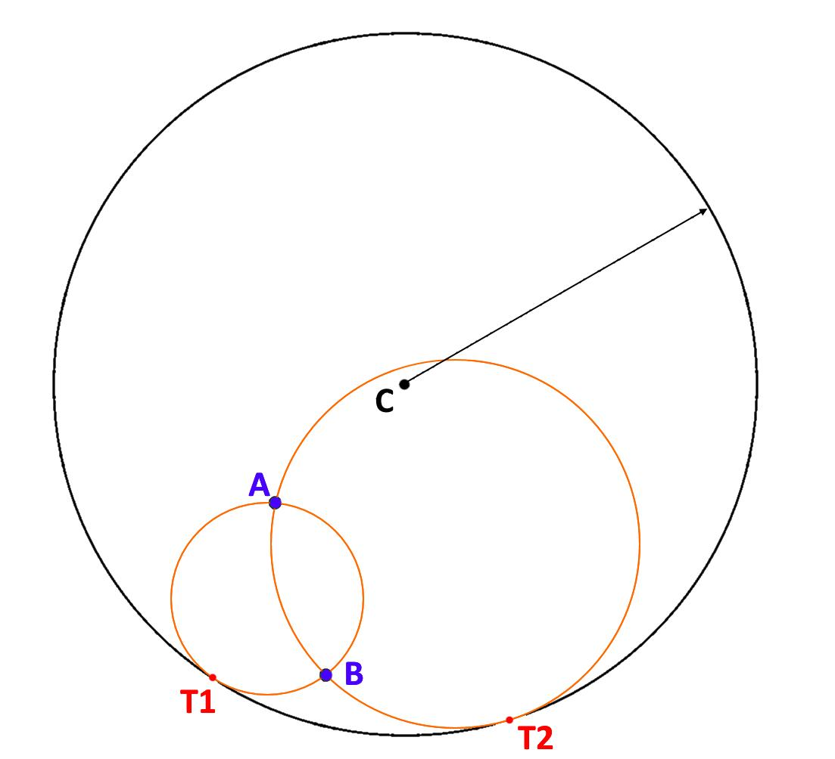

Tangent Segments at the Contact Point
# Source: AI Source: Provided by: [Data Path: Persons Table -> ID Column: 1, Name_En Column: Motasem Essam] -> From: [ChatGPT] on [7/25/2026]
At the point of internal tangency $P$, the two circles share the same tangent line.
The radii:
$$O_{1}P$$
and:
$$O_{2}P$$
lie on the same line.
Therefore, the common tangent is perpendicular to both radii:
$$\boxed{l⊥O_{1}P}$$
and:
$$\boxed{l⊥O_{2}P}$$

Real-World Examples
# Source: AI Source: Provided by: [Data Path: Persons Table -> ID Column: 1, Name_En Column: Motasem Essam] -> From: [ChatGPT] on [7/25/2026]
Internal tangency can be seen or modeled in:
- Circular rings around smaller circular objects.
- Bearings and circular components.
- Wheels inside circular tracks.
- Circular mechanical components.
- Pipes fitted inside larger circular structures.
- Circular architectural designs.
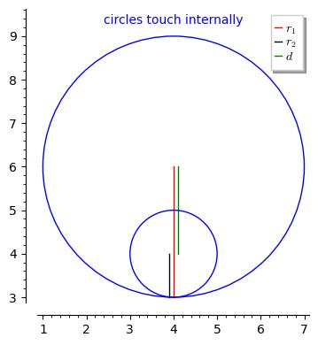

Applications
# Source: AI Source: Provided by: [Data Path: Persons Table -> ID Column: 1, Name_En Column: Motasem Essam] -> From: [ChatGPT] on [7/25/2026]
Internal tangency is important in:
- Plane Geometry
- Circle Geometry
- Coordinate Geometry
- Euclidean Geometry
- Trigonometry
- CAD
- Mechanical Engineering
- Architecture
- Robotics
- Computer Graphics
- Manufacturing
- Machine Design

Advantages
# Source: AI Source: Provided by: [Data Path: Persons Table -> ID Column: 1, Name_En Column: Motasem Essam] -> From: [ChatGPT] on [7/25/2026]
Studying internal tangency helps to:
- Understand relationships between nested circles.
- Calculate center distances.
- Solve circle geometry problems.
- Construct tangent circles.
- Analyze circular components.
- Design mechanical parts.
- Create CAD constraints.
- Analyze circular paths and boundaries.

Limitations
# Source: AI Source: Provided by: [Data Path: Persons Table -> ID Column: 1, Name_En Column: Motasem Essam] -> From: [ChatGPT] on [7/25/2026]
Internal tangency:
- Requires one circle to lie inside the other.
- Requires precise radius and center-distance conditions.
- Must be distinguished from external tangency.
- Must be distinguished from two-point intersection.
- Can be difficult to determine from approximate measurements.

Comparison with External Tangency
# Source: AI Source: Provided by: [Data Path: Persons Table -> ID Column: 1, Name_En Column: Motasem Essam] -> From: [ChatGPT] on [7/25/2026]
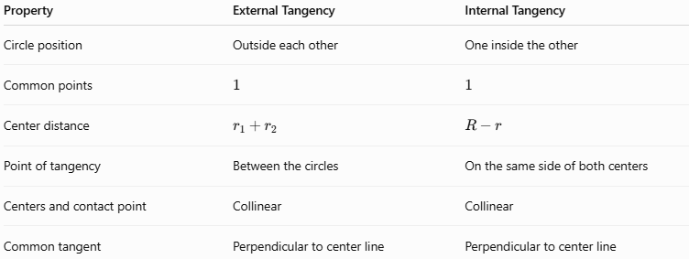
Property | External Tangency | Internal Tangency
Circle position | Outside each other | One inside the other
Common points | $$1$$ | $$1$$
Center distance | $$r_{1}+r_{2}$$ | $$R-r$$
Point of tangency | Between the circles | On the same side of both centers
Centers and contact point | Collinear | Collinear
Common tangent | Perpendicular to center line | Perpendicular to center line

Key Points
# Source: AI Source: Provided by: [Data Path: Persons Table -> ID Column: 1, Name_En Column: Motasem Essam] -> From: [ChatGPT] on [7/25/2026]
- Internal Tangency occurs when one circle lies inside another and they touch at exactly one point.
- The common point is the point of tangency.
- The number of common points is:
$$\boxed{1}$$
- The center distance is the difference between the radii:
$$\boxed{d=R-r}$$
- The larger radius is:
$$\boxed{R}$$
- The smaller radius is:
$$\boxed{r}$$
- The centers and point of tangency are collinear:
$$\boxed{O_{1}-O_{2}-P}$$
- The common tangent at the contact point is perpendicular to the line joining the centers:
$$\boxed{l⊥O_{1}O_{2}}$$

Conclusion
# Source: AI Source: Provided by: [Data Path: Persons Table -> ID Column: 1, Name_En Column: Motasem Essam] -> From: [ChatGPT] on [7/25/2026]
Internal Tangency is a geometric relationship in which one circle lies inside another circle and the two circles touch at exactly one point. The point of contact is called the point of tangency. The centers of the two circles and the point of tangency lie on the same straight line, with the center of the smaller circle between the center of the larger circle and the contact point. If the radii are $R$ and $r$, the condition for internal tangency is:
$$\boxed{d=R-r}$$
Internal tangency is an important concept in circle geometry, coordinate geometry, CAD, engineering, mechanical design, architecture, robotics, and computer graphics.

